

**IOT could**

**Real Time Cloud Monitoring of Different Aspects of Bins**

**Data Analysis and User Interface**

**WiFi/**

**LTE/3G**

 

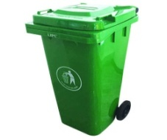 

**Optimized Route for Waste Collection**

**Smart Bins with IOT Edge Nodes**

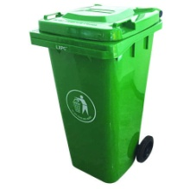

**Collection of the Wasters**

